Guidance for staff in setting up new local group websites

Version 2.2

Last updated: Dec 2017

If you have a technical query about your site, please contact

volunteering@diabetes.org.uk

Contents
 | Description | Page
1. | Introduction | 3
2. | Logging in | 3
3. | Manage group sites | 4
3.1 | Create a new local group site | 4
3.2 | Preset content on the sites | 5
3.3 | Edit a local group site | 6
3.4 | Delete a local group site | 6
4. | Manage users (group admins) | 7
4.1 | Create new users | 7
4.2 | Edit users | 8
4.3 | Delete users | 8
5. | Manage global content | 9
6. | Changing user guide link | 9
7. | Reporting Technical Issues | 10

- Introduction
This is a guide to those actions only which global admins can do:

- Create and delete group sites
- Change the name of the group
- Create, edit and delete group admins (users)
- Edit global content – this is content which features on all the group sites

As a group administrator, you can also edit the content for all group sites. To find out how to manage individual group sites, please read the local group user guide. You can access the latest version of this by logging in as a group admin and clicking on the User Guide link in the header menu:

- Logging in
Log in at https://diabetesukgroup.org/login using the global admin log in details provided by the central volunteering team. These log in details are shared by all those who have global admin rights so please don’t reset the password or share the details with others without the permission of the central volunteering team.
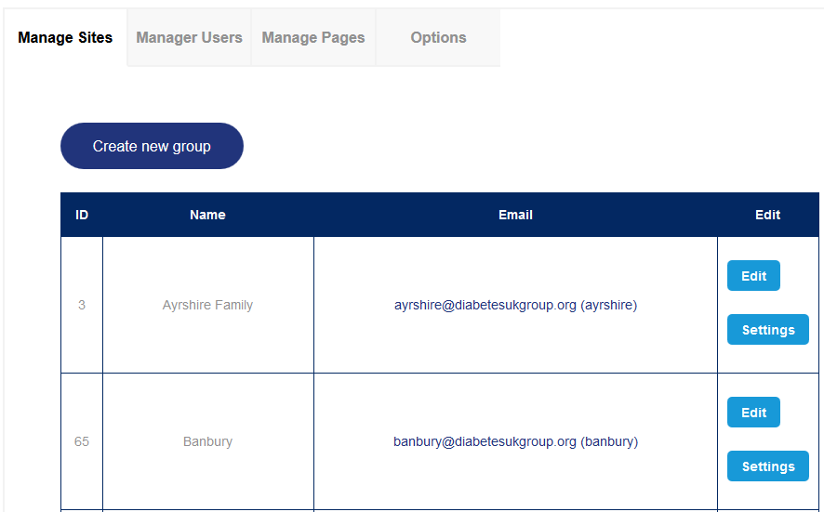
After logging in, you’ll see the following tabs in the header navigation:

Manage sites – managing individual group sites
Manage users – manage group admins
Manage pages – manage global content
Options – manage the user guide link

- Manage group sites
3.1 Create a new local group site
Under the manage sites tab, click the ‘create new group’ button.

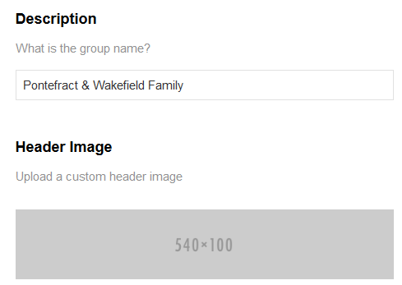
Under description, write the group’s name. This will form part of the web address for the group so please keep it short.

The group’s web address will feature the group name before diabetesgroup.org (the domain name), for example:

http://pontefract-wakefield-family.diabetesukgroup.org/

Words are automatically separated by a hyphen and any ampersands removed.

The group name will appear as it is typed into the description field on the group’s homepage, as part of the welcome message:

Take your time finalising the group’s name. Although you can change the group’s name at any time, this will only change the welcome message on the group’s homepage – the web address for the site cannot be changed once it’s been created.

Ignore the custom header image field – even if you add an image here, it doesn’t seem to appear anywhere.

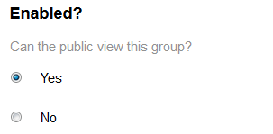
Select whether the group website is visible to the public or not.

Yes = the group site will be indexed by search engines and listed in search results. It will also be listed on the (public) directory page at http://diabetesukgroup.org/directory/.

No = the group site will only be accessible to those who know the web address.

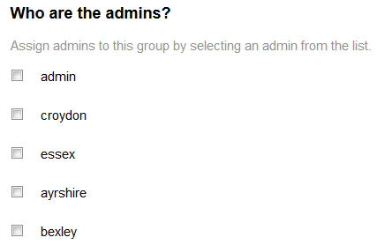
Select from the list the group admin (or admins) for the site. These users will be able to edit the content of the site.

Note that only the first part of this list is alphabetical.

If the users aren’t yet on this list, you can assign the right group for them when you add them to the system – for how to do this, see part 4 of this guide.

Click at the bottom of the page to create the group site.

3.2 Preset content on the group sites
When you first create a group site – (before the local group starts editing it -) it will be made up of a homepage, (blank) about us page and contact us page.

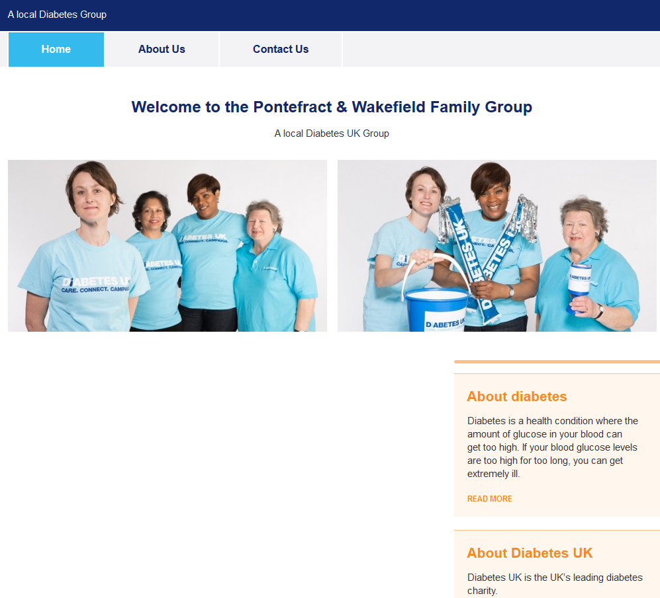
The homepage will display the group’s name in a ‘Welcome to …’ heading.

There will be temporary copy for the tag line (in dark blue bar above the menu) and the welcome copy, and two stock images - do encourage local groups to replace these with their own photos.

The page will also feature two centrally edited content blocks – About diabetes and About Diabetes UK. The content for these is the same for all group sites.

Please note: Do not change these without the permission of the central volunteering team as they will apply to all volunteer sites

The homepage will have a contact us box with the details prefilled for the Diabetes UK head office in London. It’s important that the local group replaces these with their own contact details, especially the email address. This is because any messages submitted on the group’s contact us page are sent to this email address. By default they will come to the central volunteering team.

The homepage has a Facebook link which is preset to Diabetes UK’s main Facebook group and the Twitter feed which shows @DiabetesUK’s tweets. These can be replaced by a link to the group’s Facebook page and twitter sites if they have them.

For more guidance on creating homepage copy, see the local group website user guide (accessible when logged in).

  - Edit a local group site
As a global admin, you can edit all group sites. To do this, click on the edit button for the relevant group site:
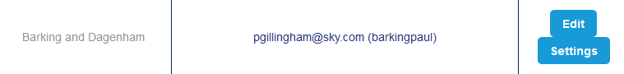

For more guidance on how to edit individual group sites, see the user guide for group admins.

  - Delete a local group site
To delete a group site, click on the settings button for the relevant group site.
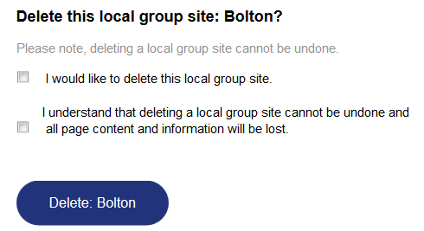

Scroll to the bottom of the page. Tick both the check boxes to confirm you wish to delete the site and hit the delete button.

PLEASE NOTE: Deleting sites cannot be undone. Once deleted, all data will be lost.

- Manage users (group admins)
Under the manage users tab, you can create and delete users, update their email address and usernames.

4.1 Create new users
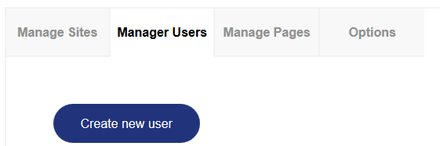
Click on the create new user button.

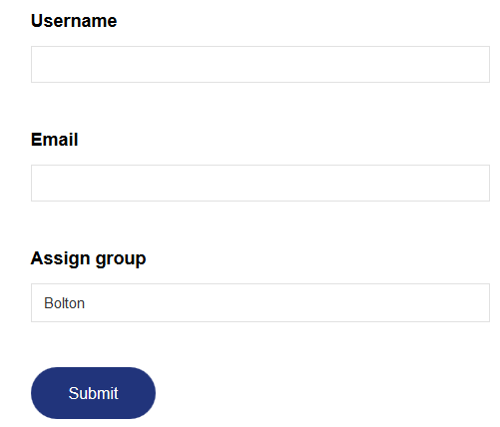
Type in a username and an email address, and assign a group for the user - this is the group site the user will be able to edit.

Hit Submit.

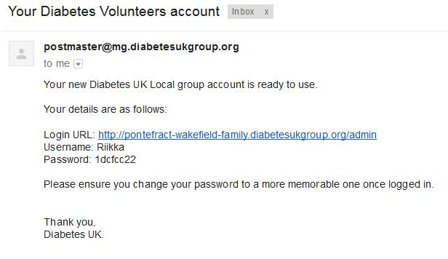
The new user will receive an email with their username and password, together with a link to the log in page for their group. Please note users can now use their email address as well as user name to login.

4.2 Edit users
You can change the user’s username and email address.
To do this, just click on the edit button, update the details on the next page and click on submit.

You cannot change the user’s password – they can reset their own password at http://diabetesukgroup.org/resetting/request. If they are logged in, they can also reset their password through settings in the global menu.

4.3 Delete users
To delete a user, click on the edit button for the user.
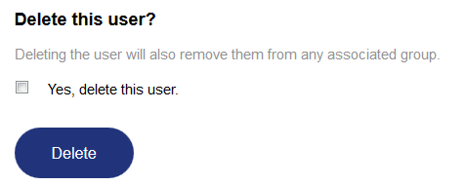
On the following page, tick the check box to confirm you wish to delete them and hit delete. Please Note: Deleting users cannot be undone.

- Manage global content
Under the manage pages tab, you can edit global content – this is content which features on all the group sites.

There are two pages - about diabetes and About Diabetes UK - which appear on all the group sites. Content for both also features on the group site homepages. Please note: This content will apply to all sites – please obtain the consent of the central volunteering team before making any changes.

These use WYSIWYG editors and you can embed YouTube videos and add links to pages and documents. The global area doesn’t have a library (where you can upload files) but you can use the Nonsense (test) group site library instead.

You can also edit the disclaimer linked from the footer.

- Change the user guide link
Under the options tab, you can manage the user guide link in the header menu:

You can link to web pages or PDFs – First save the PDF to the Library for the Nonsense (test) local group, then link to it.
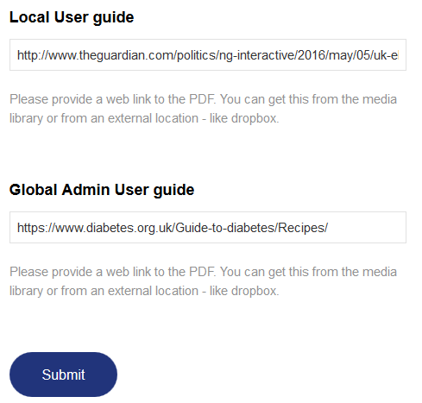
Users logged in as group admins will be able to access the page/document you link from the local user guide field.

Users logged in as global admins will be able to access the page/document you link to from the global admin user guide field.

- Reporting Technical Issues

If you experience any technical issues with a local groups website please raise them with the central volunteering team: volunteering@diabetes.org.uk. They will raise them with our digital team. Please do not report to ITLab or IT Team as it is not their responsibility.

